.

**Department of Computer Science and Engineering** | **Rajalakshmi Engineering College**

155



09- Functions

**Ex. No. : 9.1 Date: 01.06.24**



**Register No.: 231801093 Name: S.MAHALAKSHMI**

# Christmas Discount

An e-commerce company plans to give their customers a special discount for Christmas. They are planning to offer a flat discount. The discount value is calculated as the sum of all the prime digits in the total bill amount.

Write an python code to find the discount value for the given total bill amount.

## Constraints

1 <= orderValue< 10e100000 Input

The input consists of an integer orderValue, representing the total bill amount. Output

Print an integer representing the discount value for the given total bill amount. Example Input

578

Output 12

**For example:**



|  |  |
| --- | --- |
| **Test** | **Result** |
|  | |
| print(christmasDiscount(578)) | 12 |

**Program:**

def is_prime_digit(digit): return digit in [2,3,5,7] def christmasDiscount(n):

s=discount=0 prime_digitis=[2,3,5,7]

.

**Department of Computer Science and Engineering** | **Rajalakshmi Engineering College**

156

for digit in str(n): digit=int(digit)

.

**Department of Computer Science and Engineering** | **Rajalakshmi Engineering College**

157



if is_prime_digit(digit): discount+=digit

return discount

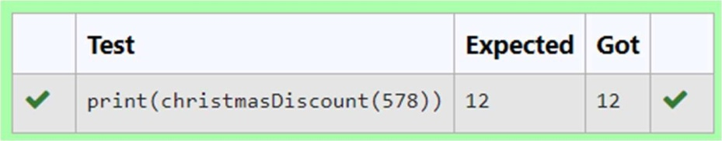

**Ex. No. : 9.2 Date: 01.06.24**

.

**Department of Computer Science and Engineering** | **Rajalakshmi Engineering College**

158



**Register No.: 231801093 Name: S.MAHALAKSHMI**

# Check Product of Digits

Write a code to check whether product of digits at even places is divisible by sum of digits at odd place of a positive integer.

Input Format:

Take an input integer from stdin. Output Format:

Print TRUE or FALSE. Example Input:

1256

Output: TRUE

Example Input: 1595

Output: FALSE

For example:



|  |  |
| --- | --- |
| **Test** | **Result** |
| print(productDigits(1256)) | True |
| print(productDigits(1595)) | False |



**Program:**

def productDigits(n): a=n

temp=[] list1=[] list2=[] rem=0 while a!=0:

rem=a%10 temp.append(rem) a=a//10

for i in range(len(temp)): if(i+1)%2==0:

list1.append(temp[i]) else:

list2.append(temp[i]) pro=1

sum=0

for i in list1: sum+=i

for i in list2: pro*=i

.

**Department of Computer Science and Engineering** | **Rajalakshmi Engineering College**

159

if pro%sum==0: return True

.

**Department of Computer Science and Engineering** | **Rajalakshmi Engineering College**

160



else:

return False

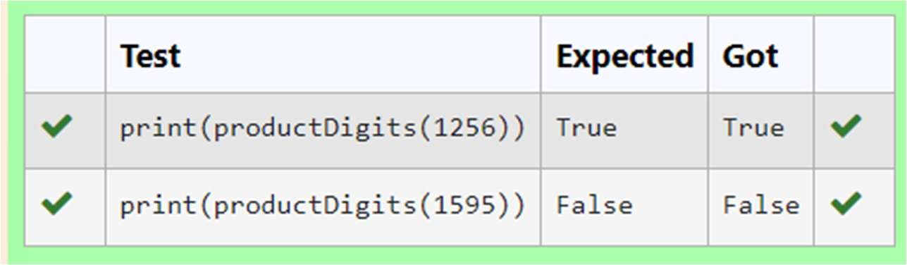



**Ex. No. : 9.3 Date: 01.06.24**

**Register No.: 231801093 Name: S.MAHALAKSHMI**

# Abundant Number

An abundant number is a number for which the sum of its proper divisors is greater than the number itself. Proper divisors of the number are those that are strictly lesser than the number.

## Input Format:

Take input an integer from stdin

## Output Format:

Return Yes if given number is Abundant. Otherwise, print No

## Example input:

12

## Output:

Yes Explanation

The proper divisors of 12 are: 1, 2, 3, 4, 6, whose sum is 1 + 2 + 3 + 4 + 6 = 16. Since sum of proper divisors is greater than the given number, 12 is an abundant number.

## Example input:

13

## Output:

No

## Explanation

The proper divisors of 13 is: 1, whose sum is 1. Since sum of proper divisors is not greater than the given number, 13 is not an abundant number.

For example:

Test Result

print(abundant(12)) Yes

print(abundant(13)) No

**Program:**

def abundant(number):

.

**Department of Computer Science and Engineering** | **Rajalakshmi Engineering College**

161

d_s=sum([divisor for divisor in range(1,number) if number % divisor == 0]) if d_s>number:

.

**Department of Computer Science and Engineering** | **Rajalakshmi Engineering College**

162



return"Yes" else:

return "No"

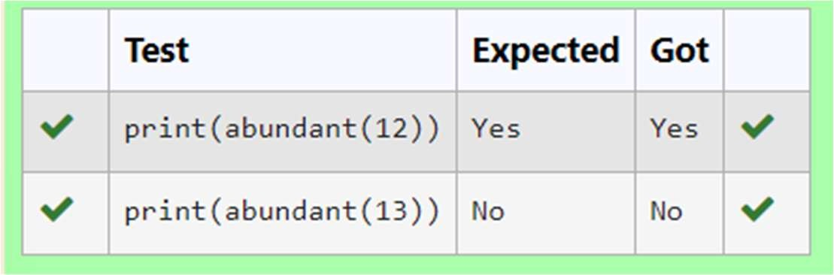



**Ex. No. : 9.4 Date: 01.06.24**

**Register No.: 231801093 Name S.MAHALAKSHMI**

# Ugly number

A number is considered to be ugly if its only prime factors are 2, 3 or 5. [1, 2, 3, 4, 5, 6, 8, 9, 10, 12, 15, …] is the sequence of ugly numbers.

Task:

complete the function which takes a number n as input and checks if it's an ugly number. return ugly if it is ugly, else return not ugly

Hint:

An ugly number U can be expressed as: U = 2^a * 3^b * 5^c, where a, b and c are nonnegative integers.

**For example:**



|  |  |
| --- | --- |
| **Test** | **Result** |
| print(checkUgly(6)) | ugly |
| print(checkUgly(21)) | not ugly |

**Program:**

def checkUgly(n): if n <= 0:

return "not ugly” while n % 2 == 0:

n //= 2

.

**Department of Computer Science and Engineering** | **Rajalakshmi Engineering College**

163

while n % 3 == 0:

.

**Department of Computer Science and Engineering** | **Rajalakshmi Engineering College**

164



n //= 3

while n % 5 == 0: n //=5

return "ugly" if n == 1 else "not ugly"

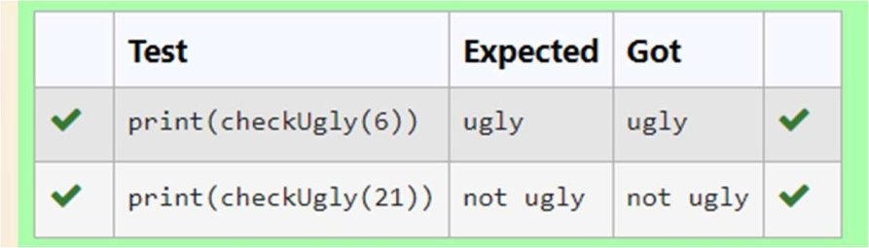



**Ex. No. : 9.5 Date: 01.06.24**

**Register No.: 231801093 Name S.MAHALAKSHMI**

# Automorphic number or not

An automorphic number is a number whose square ends with the number itself. For example, 5 is an automorphic number because 5*5 =25. The last digit is 5 which same as the given number.

If the number is not valid, it should display “Invalid input”.

If it is an automorphic number display “Automorphic” else display “Not Automorphic”.

Input Format:

Take a Integer from Stdin Output Format:

Print Automorphic if given number is Automorphic number, otherwise Not Automorphic Example input: 5 Output: Automorphic Example input: 25 Output: Automorphic Example input: 7 Output: Not Automorphic

## For example:

Test Result

print(automorphic(5)) Automorphic

**Program:**

def automorphic(n):

.

**Department of Computer Science and Engineering** | **Rajalakshmi Engineering College**

165

if(n<0):

.

**Department of Computer Science and Engineering** | **Rajalakshmi Engineering College**

166



return "Invalid input" square = n * n n_s=str(n) s_s=str(square)

if s_s.endswith(n_s): return "Automorphic"

else:

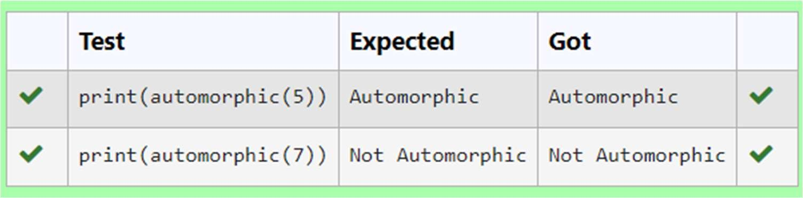return "Not Automorphic"